 

# GHARDA FOUNDATION

**GHARDA INSTITUTE OF TECHNOLOGY, LAVEL**

#### Department of Computer Engineering



**Evaluation Sheet**

Class: TE-Computer Engineeing Sem: V Subject: **Computer Networks**

#### Experiment No: 1 To study RJ45 and CAT6 Cabling and connection using crimping tool. Experiment:

Name of Student: Sanket Chandrashekhar Harvande Roll No: 19

|  |  |  |  |
| --- | --- | --- | --- |
| Sr. No. | Evaluation Criteria | Max Marks | Marks Obtained |
| 1 | Practical Performance | 8 |  |
| 2 | Oral | 5 |  |
| 3 | Timely Submission | 2 |  |
|  | Total | 15 |  |

Signature of Subject Teacher

(Mr. S. S. Tathare)

**Aim**: Study of different types of Network cables and Practically implement the cross-wired cable and straight through cable using crimping tool.

**Apparatus (Components):** RJ-45 connector, Crimping Tool, Twisted pair Cable

**Procedure:** To do these practical following steps should be done:

**1.** Start by stripping off about 2 inches of the plastic jacket off the end of the cable. Be very careful at this point, as to not nick or cut into the wires, which are inside. Doing so could alter the characteristics of your cable, or even worse render is useless. Check the wires, **one more time** for nicks or cuts. If there are any, just whack the whole end off, and start over.

**2.** Spread the wires apart, but be sure to hold onto the base of the jacket with your other hand. You do not want the wires to become untwisted down inside the jacket. Category 5 cable must only have 1/2 of an inch of 'untwisted' wire at the end; otherwise it will be 'out of spec'. At this point, you obviously have ALOT more than 1/2 of an inch of un-twisted wire.

**3.** You have 2 end jacks, which must be installed on your cable. If you are using a pre-made cable, with one of the ends whacked off, you only have one end to install - the crossed over end. Below are two diagrams, which show how you need to arrange the cables for each type of cable end. Decide at this point which end you are making and examine the associated picture below.

## Diagram shows you how to prepare Cross wired connection

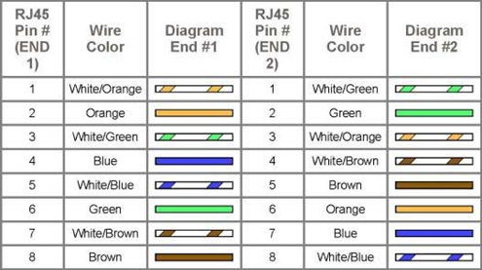

**Diagram shows you how to prepare straight through wired connection**

|  |  |
| --- | --- |
|  |  |
|  |  |

Conclusion: Thus the study of RJ45 and CAT6 Cabling and connection using crimping tool is done.